Case Study 1.6: Getting on when catastrophy strikes . V 1.1
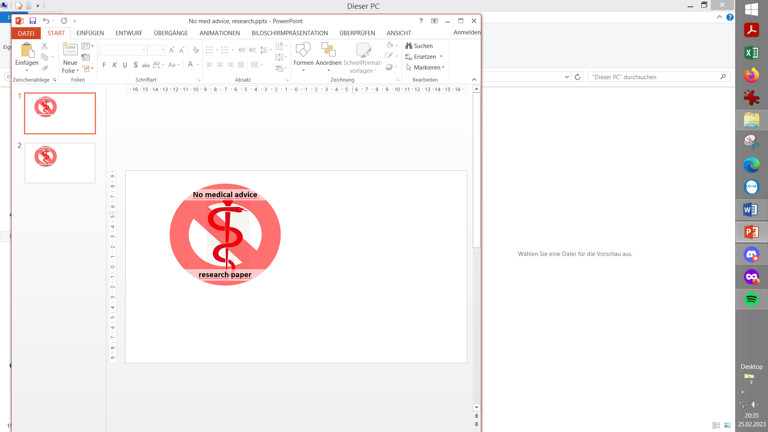

This case is about sorting out technical root causes for bad loop
performance
- before jumping too fast into interventions, or even settings changes

Method

FCL (no carb inputs, no user boli) with dev variant of AAPS 3.2.0.4 w/autoISF 3.0.1:
Lyumjev 100 (DIA 8.5 h) in Combo pump w/ 10mm Teflon cannula (0-48h)
2 x G6 overlapping (see case study 1.5; sensors used ~ d3 – d15; xDrip, no smoothing in AAPS)
TDD ~ 40 U; profile basal ~ 14 U (0.41…0.75 U/h); profile_ISF 36…44 mg/dl/U; iobTH% = 0.6
Key settings*) for entire meal spectrum (~ 20 … 90 g carb per meal):
SMB size limited at ~ 3.5 U (=2.9 x 120 minutes basal)
autoISFmax = 2.9; SMB delivery ratio = 0.75 fixed
bgAccel_ISF_weight = 0.22; break_weight 0.12; lower_ISF-range_weight 0.7; higher_ISF-range_weight 0.1; pp_ISF_weight = 0.03; dura_ISF_weight 0.8
Activity modifies sensitivity w scale factors 1.2 (active) and 0.3 (in-active)
*) Caution: Do not copy settings from others,
not even for starting your tuning.
Why, see FCL e-book section 4.1.

Values keep climbing between lunch and bedtime
Until about 13:30 h everything was fairly normal. Fortunately, this included getting some significant SMBs for the lunch from my FCL .
After 13:30 we see two clusters of problems.
13:30 – 18:00: Hardly any insulin is given, and the IOB curve swings from around 8 U down to zero. SMBs stopped after 13:30 as expected with iob>iobTH. But the many orange warnings “pump connected?” show that, for a period of nearly 4 hours, probably the Bluetooth connection to the pump was not, or only rarely, given. I first did not realize this situation because bg actually remained in range and came down towards target by around 15:00.
However, between 16:00 and 19:00 bg kept “unlogically” rising (I had not eaten anything). This made me (shortly before 18:00) check the situation. Only then I became aware that these (sometimes seen, but here super frequently occurring) “pump connected?” warnings are meaningful. As I had pump and phone always in proximity, I quickly realized that the over 10d old pump battery must be the culprit, and exchanged it at 18:00 h.
My FCL immediately served me with sizeable SMBs, which was important also for going soon into dinner time.

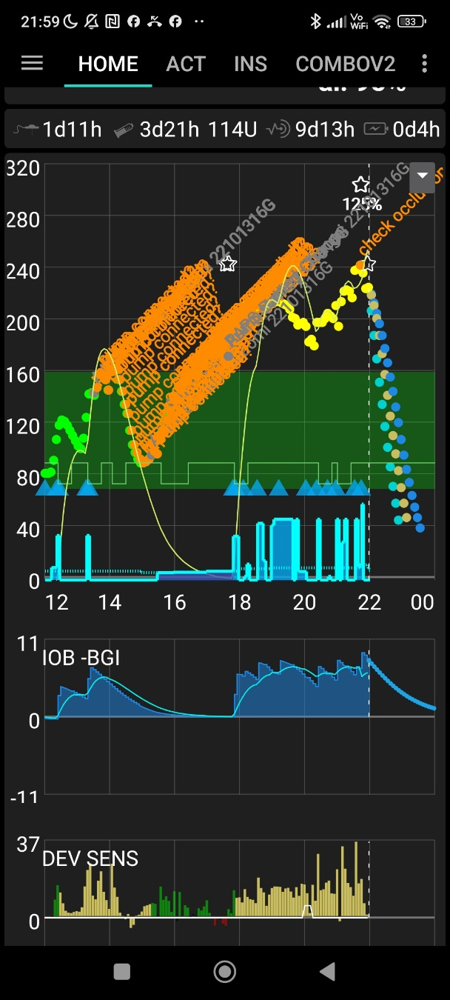
19:00-23:00: Dinner started at bg above range, and iob bouncing around iobTH. Therefore, it was not unexpected that bg values hung above target for a while.
Yet, as midnight approached I got concerned that bg values kept rising, despite high IOB. This per se is a warning sign for potential occlusion. (Also, I have an Automation that does a “check occlusion” warning.)
Another sign pointing to occlusion: Compare carb deviations for lunch (12-15h integral of yellow DEV) to those resulting for dinner (18-22h integral of yellow DEV). There just wasn’t a multiple amount of carbs to be digested, and to consume insulin (that the loop saw consumed, though, and had to “explain” with lots of carbs supposedly absorbed). The puzzle resolves if fake high iob led to fake high carbs absorbed.
To resolve the occlusion I had, around 23:00 h, to:
- Change cannula. Although this one was not 48 hrs old, it seemed the culprit. Severe stinging at the last SMBs should have been a warning sign, too. When pulling out the old cannula, indeed the adhesive patch was moist and had an insulin smell. Also I noticed a slightly red color, from blood flowing back out with some of the insulin. (See also case study 1.2)
- Make an estimate (on the safe, low side), how much of the insulin actually may have been over-reported (“fake”). Erase that amount in AAPS/Treatments, and quickly add it back via pen, and record it (“Do not bolus, record only”. - For this step, I had to briefly add an Insulin button on the bottom of my FCL AAPS screen).

Crisis at bedtime
Having recognized and principally resolved the causes underlying the reported problems still left me with a huge issue now, around midnight:
As I need to finally go sleep, bg values are still way above range, and super rapidly falling (even a warning “42 g carbs required” showed at some point).
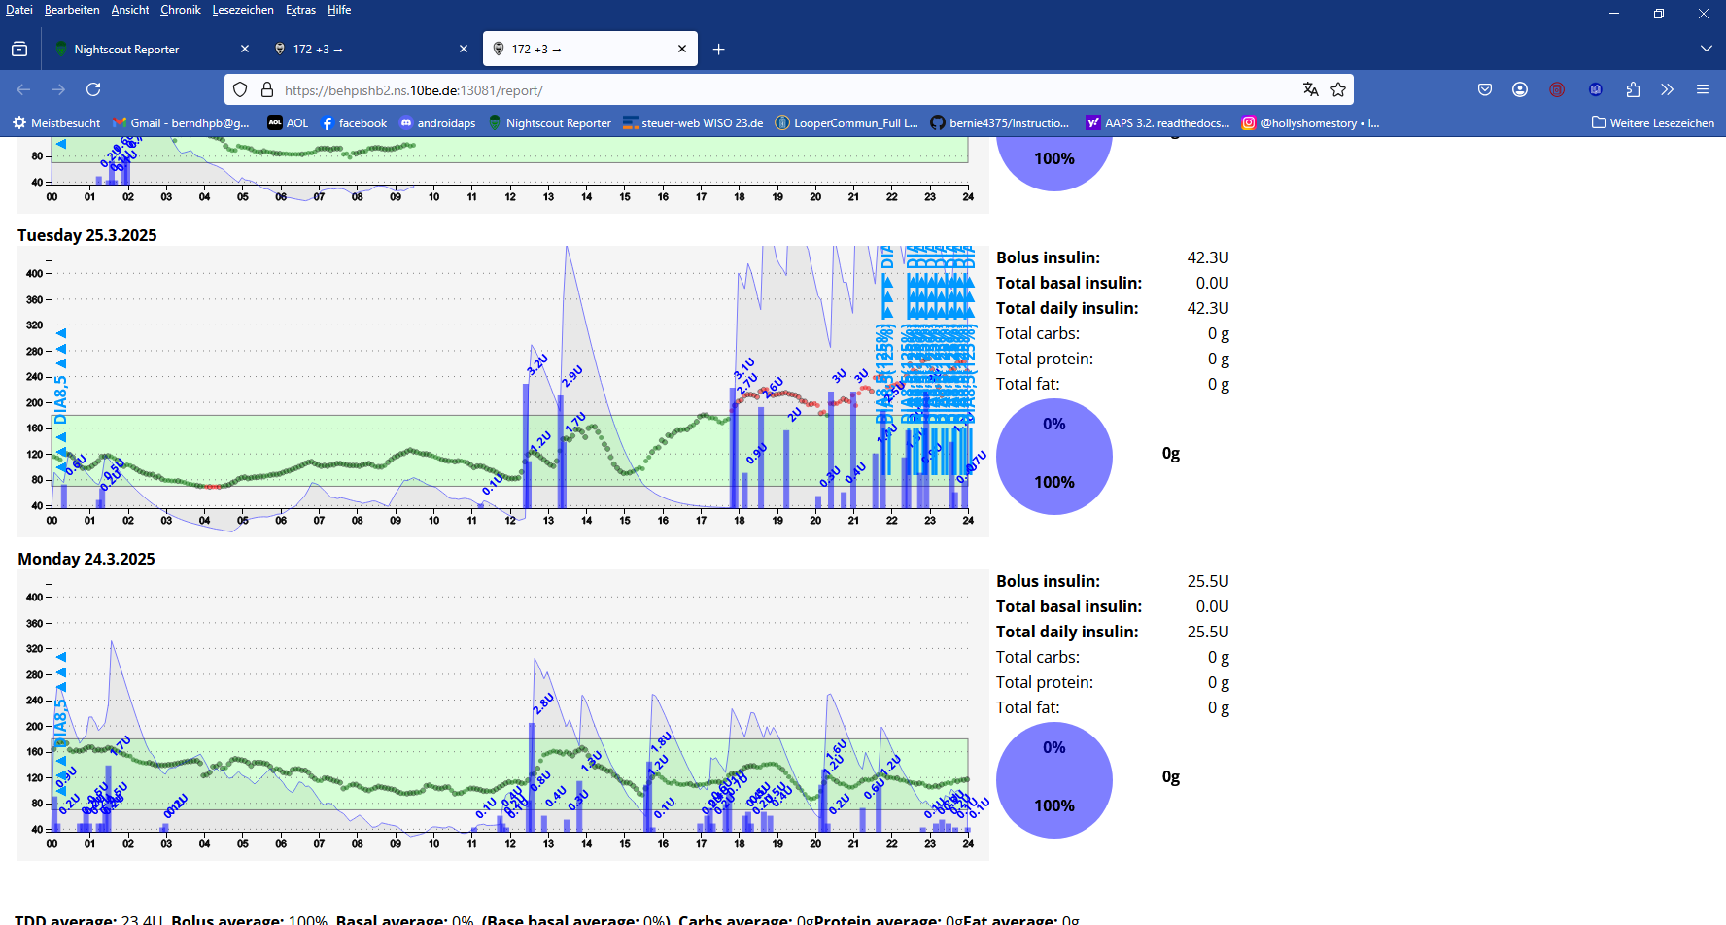
What made the situation unsafe was: I had to guess the amount of over-reported (and erased, then via pen replaced) iob
If I did that guess about right..
one indication I used was my typical required iob of 6 or 7U in the peak of the IOB curve, to the 10-11 seen on this day of catastrophe striking
…, then the “carbs required” warnings should soon stop, and the decline “soften” and “swing in” towards bg target.
So, I had to wait at least another 3 x 5 minutes to see that trend.
Indeed, it took 10 minutes for “carbs requ.” warnings to disappear, and for the bg curve leaving the steep trajectory towards a hypo . So I went to sleep.

Things quieting down at night
When the occlusion was resolved, the loop was able to fully do its job again.
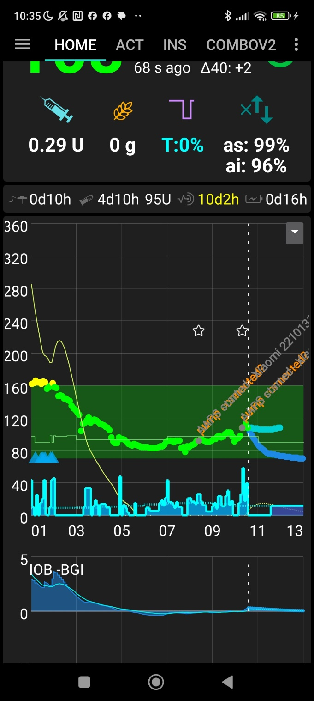
Down regulation towards target, and iob around zero, made for a perfect start into the next day.

Note: The target or TT changes during the night (thin green line around bg=100) come from my settings and Automations for managing nights, with/without SMBs as needed. (Described in FCL e-Book section 5.1.2 Adjunct Autom.).
The temp. SMB-off slows down the corrections to target, and therefore enhances safety against hypos at night (which, notably with autoISF going 24/7, could also result from compression lows. There actually was one, shortly after 03 am. See also Case Study 5.3).

:
Preceeding day
The day with 2 serious technical problems - resulting in worst TIR (72%) I ever saw - was preceeded by a day with pretty good performance @ 100% TIR:

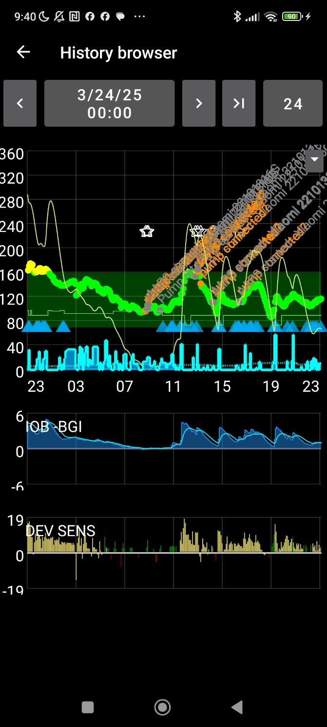
On the preceding morning, there was also a down-regulation in the night towards target. Note that my green range ends at 160 mg/dl, so the yellow part is still in range (up to 180), and that day my FCL managed with 100% TIR.
Compare iob charts: On the problem day,23/03, see chart on 1st page) iob went several time to 10U. On the preceding day (History Browser, 3/24) with good FCL meal management, and in absence of occlusion problems, it only went to about 5U. (A high carb meal it would go typically to 7, max. 8 U).
Also on this preceding day, there were a couple of orange warnings “pump connected?”. I could have prevented one of my two technical problems that I had next day, by taking these “self-resolving” brief problems more seriously, and exchange my pump battery already then! “

Following day, and Statistics
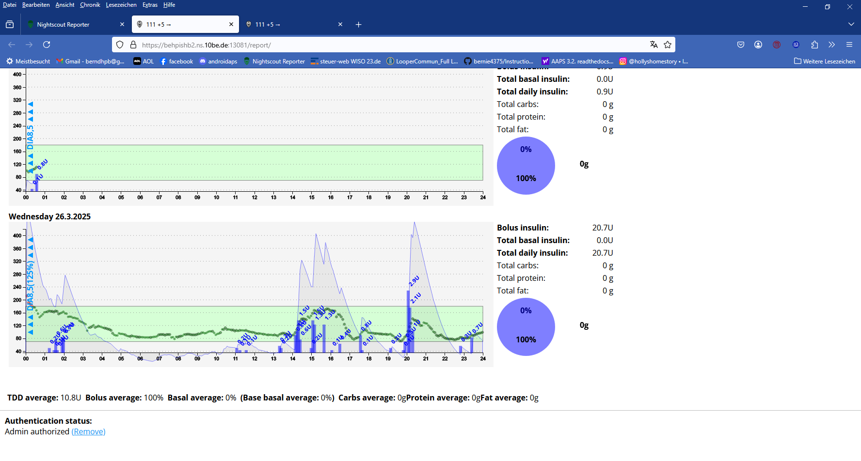
Right after midnight (after my problem day - this is where 1% high is coming from), we see again that the nighttime allows the loop to move towards bg target, and start the next day in a fairly straight line.
As the AAPS screen (below) shows, there were two major meals, driving iob up to about 7 U. The curve remained in range all the time.
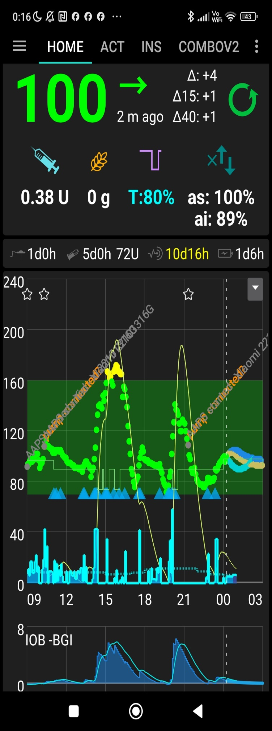
A day with only 72% TIR
- requires two adjacent days of 99-100% TIR to not depress the average to below 90% (see my actual achievement, below)
- likewise, having an average 93% TIR on all other days (as I actually had, in line with my personal long term average) brings a 90% TIR for that week (last line of the table below)
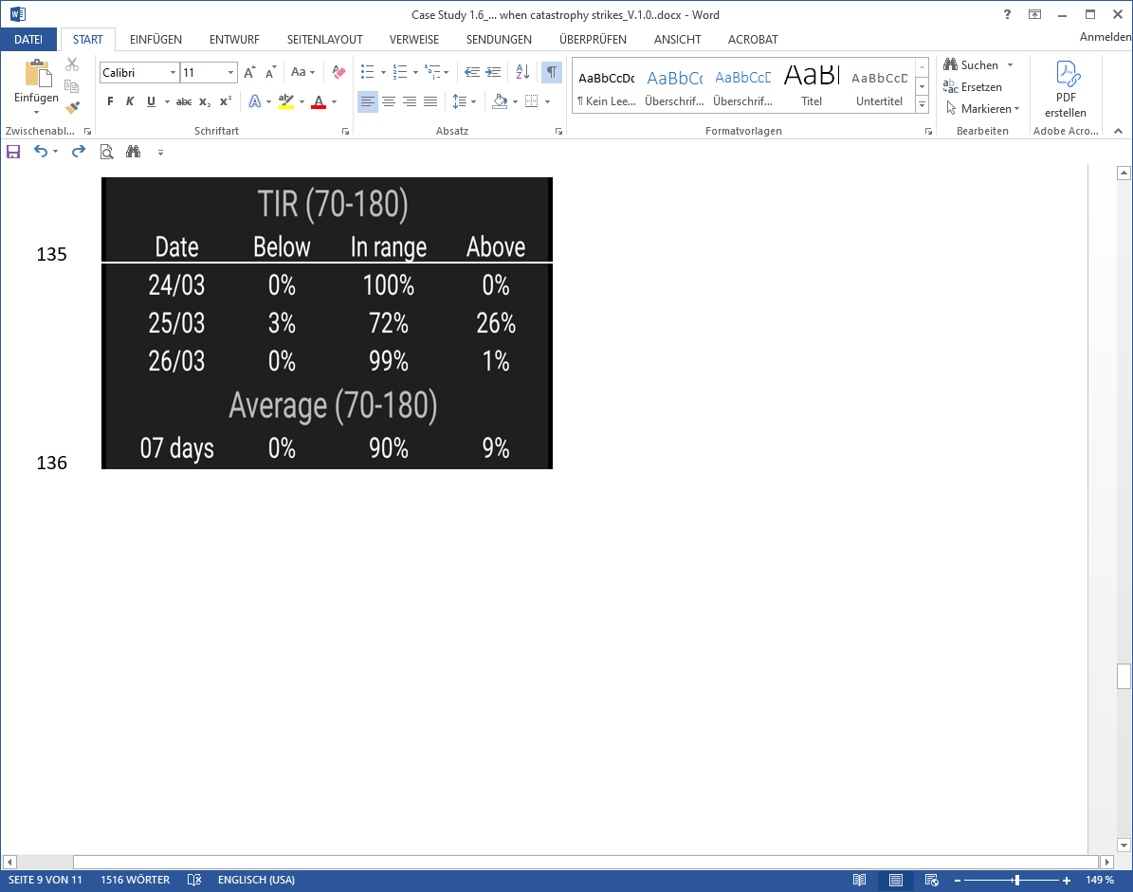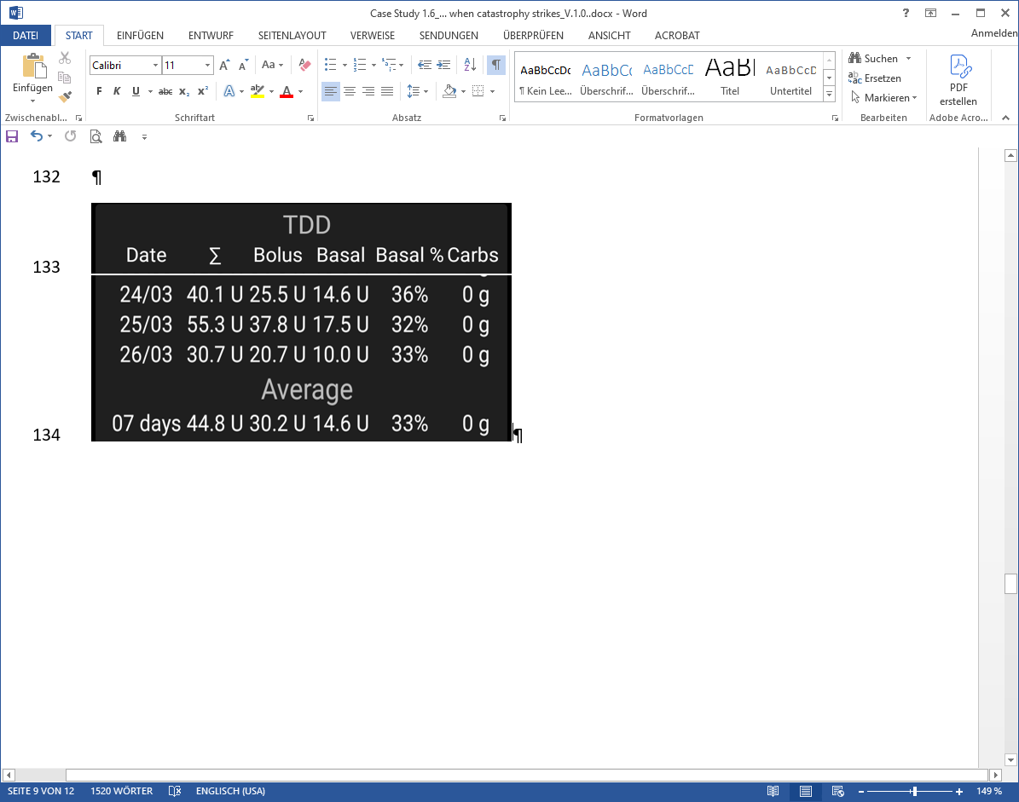
Note: Full Closed Loop. Carbs = 0 g results from not making any carb inputs.
The problem day reports TDD = 55.3 U which is 28% above the average (43.0) of the other days. This points to:
- some of the “12.3 U extra” insulin had not actually entered my body
- another part was “borrowed from basal” of the next calendar day because my loop had to fight the high still around midnight (see 26/03 charts)
- yet another part might be due to eating above average

Off topic remark: I do not use dynamicISF, so I did not have to fear that the over 40% drop in TDD from 25/03 to 26/03 will suggest insulin resistance, and trigger too high iob next day.

Key learning points
This case study is a reminder that things can easy deteriorate (also further than we have seen above) if there is no attention to having the technical pre-requisites for a functioning loop in place 24/7.
These key pre-requisites are:
- No BlueTooth gaps over 10-20 minutes => Keep components in proximity, and well powered
- “True” iob values => Avoid occlusions (Attention to cannula site, age, insertion depth; to stinging sensations at SMBs, to smelliness of patch from insulin coming back out ; see also Case Study 1.1)
- “True” bg values => Avoid jumpy or wrongly calibrated/drifting CGM.
This third problem was not involved in the presented case (but see Case Study 1.3). Actually, I rarely have a problem in that area because I use two overlapping G6 (both arms, started on different days. See Case Study 1.5).
Looping makes no sense even if just 1 of these pre-requisites is frequently lacking. It could be proven that people who do not pay sufficient attention to these 3 points would do better with just a insulin pen and a bg meter (which, after all, is the way the older ones of us did OK for many years).

Furthermore, this case should teach us to always first rule-out technical malfunctions.
Tuning settings only makes sense on (and for) days with smooth technical operation.

Addendum
As some readers may not be familiar with the AAPS screens that I mainly use, I can give here also a (in my opinion not equally useful) Nightscout chart:
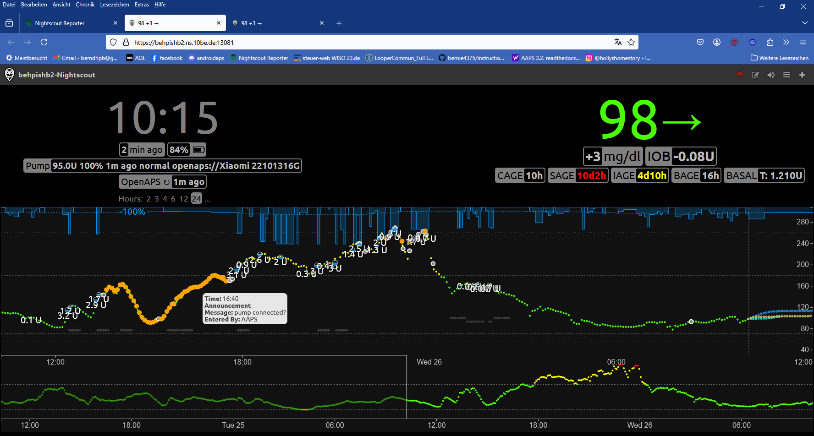
I do not really use this type of chart because it has no insulin activity and IOB info. Also, the glucose chart always looks unspectacular because the y axis is shrunk short, and the x axis is too much stretched out. A positive is that it shows all the SMB sizes; they are not readable, though, as, in FCL, I get SMBs very often (In AAPS, I can pull up the list of all SMBs given via a tab on the main screen).

